October 2024 Lunch @ USD 399

Sunday | Monday | Tuesday | Wednesday | Thursday | Friday | Saturday
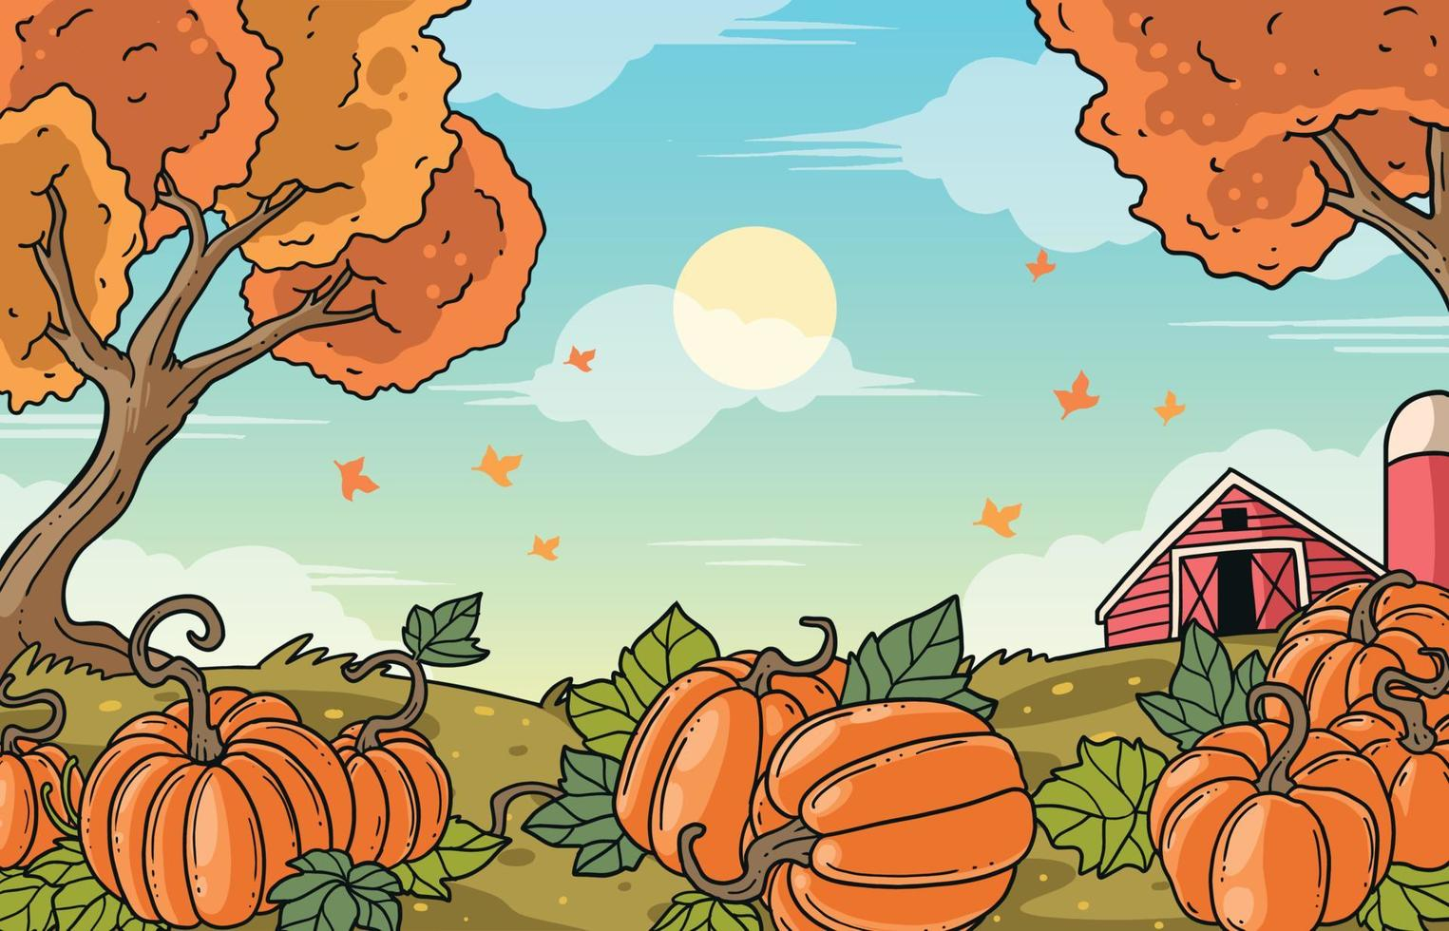 | This institution is an equal opportunity provider. | 1  BBQ Chicken  Whole Wheat Roll  Baked Beans  Creamy Coleslaw  Mangos  Milk | 2  White Chicken Chili  Cornbread  Fresh Veggies  Banana  Milk | 3  Pizza  Broccoli  Cottage Cheese  Tropical Fruit  Milk | 4 | 5
6 | 7  Pulled Pork on a Bun  Tater Tots  Cooked Carrots  Mandarin Oranges  Milk | 8  Chili Cornbread Casserole  Cauliflower  Berry Blend  Milk | 9  Corn Dog  Curly Fries  Green Beans  Fruit Cocktail  Snickerdoodle  Milk | 10  Chicken Quesadilla  Tortilla Chips  Black Bean & Corn Salsa Milk  Refried Beans  Honeydew Melon | 11 | 12
13 | 14  Hamburger on a Bun  w/Condiments  Oven Fries  Crockpot Corn  Rosy Applesauce  Milk | 15  Chili  Crackers  Peaches  Cinnamon Roll  Cottage Cheese  Milk | 16  Chicken Nuggets  Whole Wheat Roll  Mashed Potatoes/Gravy  Seasoned Peas  Pears Milk | 17  Bierocks  Sun Chips  Green Bean Fries  Pineapple  Milk | 18 | 19
20 | 21  Hot Ham & Cheese on a Bun  Potato Wedges  Cooked Carrots  Fruit Cocktail  Milk | 22  Pizza  Caesar Salad  Celery w/Peanut Butter  Mandarin Oranges  Milk | 23  Tater Tot Casserole  Corn  Texas Toast  Banana  Milk | 24  Lasagna  Garlic Bread Stick  Vegetable Blend  Mandarin Oranges  Chocolate Chip Cookie Milk | 25 | 26
27 | 28  Chicken Nuggets  Seasoned Brown Rice  Asian Vegetables  Tropical Fruit  Milk | 29  Super Nachos  Refried Beans  Edamame  Fruit Salad  Milk | 30  Breakfast for Lunch  Biscuit & Gravy  Scrambled Eggs  Hash Brown Pattie  Sausage Pattie  Orange Juice  Fresh Veg. Milk | 31  Ghostly Little Smokies  Batty Mac & Cheese  Vampire Vines  Witch Watermelon  Halloween Punch  Milk | MENUS ARE SUBJECT TO CHANGE WITHOUT PRIOR NOTICE | 